Correlation and Cross-correlation Analysis
# Reading the dataset in R
> lake = read.csv('C:\\Users\\Public\\XAI\\LakeXAI.csv', header = TRUE)
> # Installing/calling packages/libraries
> library(jtools)
> library(ISLR)
> library(MASS)
> # Getting the working directory
> getwd()
[1] "C:/Users/Public/XAI"
> setwd("C:/Users/Public/XAI")
> set.seed(1)
> summary(lake) # Summary
T R_E R_AT
Length:108 Min. : 0.2447 Min. :21.72
Class :character 1st Qu.: 0.7892 1st Qu.:26.86
Mode :character Median : 7.1165 Median :28.69
Mean :20.9922 Mean :28.37
3rd Qu.:44.9217 3rd Qu.:30.63
Max. :75.9109 Max. :33.22
R_P G_E G_AT G_P
Min. : 0.0000 Min. : 0.200 Min. :20.75 Min. : 0.00
1st Qu.: 0.0525 1st Qu.: 4.975 1st Qu.:25.38 1st Qu.: 0.00
Median : 4.3100 Median : 9.700 Median :30.27 Median : 0.00
Mean : 41.8581 Mean : 9.208 Mean :28.91 Mean : 24.37
3rd Qu.: 72.3175 3rd Qu.:13.625 3rd Qu.:31.68 3rd Qu.: 27.07
Max. :229.9700 Max. :16.800 Max. :33.80 Max. :209.70
R_LL G_LL
Min. :280.5 Min. :278.3
1st Qu.:281.1 1st Qu.:279.4
Median :281.4 Median :279.7
Mean :281.4 Mean :279.8
3rd Qu.:281.8 3rd Qu.:280.2
Max. :282.4 Max. :280.8
> # install.packages("Hmisc")
> library(Hmisc)
> lake = (lake[,2:9])
> rp_values = rcorr(as.matrix(lake))
> rp_values
R_E R_AT R_P G_E G_AT G_P R_LL G_LL
R_E 1.00 0.22 0.91 -0.90 0.39 0.79 -0.24 -0.54
R_AT 0.22 1.00 0.11 -0.33 0.82 0.02 -0.52 -0.49
R_P 0.91 0.11 1.00 -0.80 0.34 0.89 -0.31 -0.57
G_E -0.90 -0.33 -0.80 1.00 -0.45 -0.70 0.18 0.49
G_AT 0.39 0.82 0.34 -0.45 1.00 0.23 -0.61 -0.66
G_P 0.79 0.02 0.89 -0.70 0.23 1.00 -0.19 -0.45
R_LL -0.24 -0.52 -0.31 0.18 -0.61 -0.19 1.00 0.86
G_LL -0.54 -0.49 -0.57 0.49 -0.66 -0.45 0.86 1.00

n= 108

P
R_E R_AT R_P G_E G_AT G_P R_LL G_LL
R_E 0.0221 0.0000 0.0000 0.0000 0.0000 0.0143 0.0000
R_AT 0.0221 0.2491 0.0004 0.0000 0.8547 0.0000 0.0000
R_P 0.0000 0.2491 0.0000 0.0004 0.0000 0.0011 0.0000
G_E 0.0000 0.0004 0.0000 0.0000 0.0000 0.0584 0.0000
G_AT 0.0000 0.0000 0.0004 0.0000 0.0150 0.0000 0.0000
G_P 0.0000 0.8547 0.0000 0.0000 0.0150 0.0504 0.0000
R_LL 0.0143 0.0000 0.0011 0.0584 0.0000 0.0504 0.0000
G_LL 0.0000 0.0000 0.0000 0.0000 0.0000 0.0000 0.0000
> library(correlation)
> rpvalues = correlation::correlation(lake, include_factors = TRUE, method = "auto")
> rpvalues
# Correlation Matrix (auto-method)

Parameter1 | Parameter2 | r | 95% CI | t(106) | p
---------------------------------------------------------------------
R_E | R_AT | 0.22 | [ 0.03, 0.39] | 2.32 | 0.110
R_E | R_P | 0.91 | [ 0.88, 0.94] | 23.24 | < .001***
R_E | G_E | -0.90 | [-0.93, -0.85] | -20.67 | < .001***
R_E | G_AT | 0.39 | [ 0.22, 0.54] | 4.40 | < .001***
R_E | G_P | 0.79 | [ 0.71, 0.85] | 13.35 | < .001***
R_E | R_LL | -0.24 | [-0.41, -0.05] | -2.49 | 0.100
R_E | G_LL | -0.54 | [-0.66, -0.39] | -6.63 | < .001***
R_AT | R_P | 0.11 | [-0.08, 0.29] | 1.16 | 0.498
R_AT | G_E | -0.33 | [-0.49, -0.16] | -3.66 | 0.004**
R_AT | G_AT | 0.82 | [ 0.75, 0.87] | 14.70 | < .001***
R_AT | G_P | 0.02 | [-0.17, 0.21] | 0.18 | 0.855
R_AT | R_LL | -0.52 | [-0.64, -0.37] | -6.26 | < .001***
R_AT | G_LL | -0.49 | [-0.62, -0.33] | -5.75 | < .001***
R_P | G_E | -0.80 | [-0.86, -0.71] | -13.50 | < .001***
R_P | G_AT | 0.34 | [ 0.16, 0.50] | 3.69 | 0.004**
R_P | G_P | 0.89 | [ 0.84, 0.92] | 19.68 | < .001***
R_P | R_LL | -0.31 | [-0.47, -0.13] | -3.37 | 0.008**
R_P | G_LL | -0.57 | [-0.69, -0.43] | -7.18 | < .001***
G_E | G_AT | -0.45 | [-0.59, -0.28] | -5.13 | < .001***
G_E | G_P | -0.70 | [-0.79, -0.59] | -10.22 | < .001***
G_E | R_LL | 0.18 | [-0.01, 0.36] | 1.91 | 0.202
G_E | G_LL | 0.49 | [ 0.33, 0.62] | 5.76 | < .001***
G_AT | G_P | 0.23 | [ 0.05, 0.40] | 2.47 | 0.100
G_AT | R_LL | -0.61 | [-0.71, -0.47] | -7.87 | < .001***
G_AT | G_LL | -0.66 | [-0.75, -0.54] | -9.05 | < .001***
G_P | R_LL | -0.19 | [-0.36, 0.00] | -1.98 | 0.202
G_P | G_LL | -0.45 | [-0.59, -0.29] | -5.21 | < .001***
R_LL | G_LL | 0.86 | [ 0.80, 0.90] | 17.17 | < .001***

p-value adjustment method: Holm (1979)
Observations: 108

>

# Creating a report of the correlation test
> #install.packages("remotes")
> #install.packages("report")
> #remotes::install_github("easystats/report")
> library(report)
> # R_LL and G_LL
> LLRG = cor.test(lake$R_LL, lake$G_LL)
> LLRG

Pearson's product-moment correlation

data: lake$R_LL and lake$G_LL
t = 17.173, df = 106, p-value < 2.2e-16
alternative hypothesis: true correlation is not equal to 0
95 percent confidence interval:
0.7980428 0.9006677
sample estimates:
cor
0.8576719

> report(LLRG)
Effect sizes were labelled following Funder's (2019) recommendations.

The Pearson's product-moment correlation between lake$R_LL and
lake$G_LL is positive, statistically significant, and very large (r =
0.86, 95% CI [0.80, 0.90], t(106) = 17.17, p < .001)

>

> # LL_R and climate variables
>
> # E_R
> LLRER = cor.test(lake$R_LL, lake$R_E)
> report(LLRER)
Effect sizes were labelled following Funder's (2019) recommendations.

The Pearson's product-moment correlation between lake$R_LL and
lake$R_E is negative, statistically significant, and medium (r =
-0.24, 95% CI [-0.41, -0.05], t(106) = -2.49, p = 0.014)
>
> # E_G
> LLREG = cor.test(lake$R_LL, lake$G_E)
> report(LLREG)
Effect sizes were labelled following Funder's (2019) recommendations.

The Pearson's product-moment correlation between lake$R_LL and
lake$G_E is positive, statistically not significant, and small (r =
0.18, 95% CI [-6.51e-03, 0.36], t(106) = 1.91, p = 0.058)
>
> # AT_R
> LLRATR = cor.test(lake$R_LL, lake$R_AT)
> report(LLRATR)
Effect sizes were labelled following Funder's (2019) recommendations.

The Pearson's product-moment correlation between lake$R_LL and
lake$R_AT is negative, statistically significant, and very large (r =
-0.52, 95% CI [-0.64, -0.37], t(106) = -6.26, p < .001)
>
> # AT_G
> LLRATG = cor.test(lake$R_LL, lake$G_AT)
> report(LLRATG)
Effect sizes were labelled following Funder's (2019) recommendations.

The Pearson's product-moment correlation between lake$R_LL and
lake$G_AT is negative, statistically significant, and very large (r =
-0.61, 95% CI [-0.71, -0.47], t(106) = -7.87, p < .001)
>
> # P_R
> LLRPR = cor.test(lake$R_LL, lake$R_P)
> report(LLRPR)
Effect sizes were labelled following Funder's (2019) recommendations.

The Pearson's product-moment correlation between lake$R_LL and
lake$R_P is negative, statistically significant, and large (r = -0.31,
95% CI [-0.47, -0.13], t(106) = -3.37, p = 0.001)
>
> # P_G
> LLRPG = cor.test(lake$R_LL, lake$G_P)
> report(LLRPG)
Effect sizes were labelled following Funder's (2019) recommendations.

The Pearson's product-moment correlation between lake$R_LL and
lake$G_P is negative, statistically not significant, and small (r =
-0.19, 95% CI [-0.36, 2.52e-04], t(106) = -1.98, p = 0.050)

#############G_LL and climate variables##################
> # LL_G and climate variables
>
> # E_R
> LLGER = cor.test(lake$G_LL, lake$R_E)
> report(LLGER)
Effect sizes were labelled following Funder's (2019) recommendations.

The Pearson's product-moment correlation between lake$G_LL and
lake$R_E is negative, statistically significant, and very large (r =
-0.54, 95% CI [-0.66, -0.39], t(106) = -6.63, p < .001)
>
> # E_G
> LLGEG = cor.test(lake$G_LL, lake$G_E)
> report(LLGEG)
Effect sizes were labelled following Funder's (2019) recommendations.

The Pearson's product-moment correlation between lake$G_LL and
lake$G_E is positive, statistically significant, and very large (r =
0.49, 95% CI [0.33, 0.62], t(106) = 5.76, p < .001)
>
> # AT_R
> LLGATR = cor.test(lake$G_LL, lake$R_AT)
> report(LLGATR)
Effect sizes were labelled following Funder's (2019) recommendations.

The Pearson's product-moment correlation between lake$G_LL and
lake$R_AT is negative, statistically significant, and very large (r =
-0.49, 95% CI [-0.62, -0.33], t(106) = -5.75, p < .001)
>
> # AT_G
> LLGATG = cor.test(lake$G_LL, lake$G_AT)
> report(LLGATG)
Effect sizes were labelled following Funder's (2019) recommendations.

The Pearson's product-moment correlation between lake$G_LL and
lake$G_AT is negative, statistically significant, and very large (r =
-0.66, 95% CI [-0.75, -0.54], t(106) = -9.05, p < .001)
>
> # P_R
> LLGPR = cor.test(lake$G_LL, lake$R_P)
> report(LLGPR)
Effect sizes were labelled following Funder's (2019) recommendations.

The Pearson's product-moment correlation between lake$G_LL and
lake$R_P is negative, statistically significant, and very large (r =
-0.57, 95% CI [-0.69, -0.43], t(106) = -7.18, p < .001)
>
> # P_G
> LLGPG = cor.test(lake$G_LL, lake$G_P)
> report(LLRPG)
Effect sizes were labelled following Funder's (2019) recommendations.

The Pearson's product-moment correlation between lake$R_LL and
lake$G_P is negative, statistically not significant, and small (r =
-0.19, 95% CI [-0.36, 2.52e-04], t(106) = -1.98, p = 0.050)

# Time series plot
> lake_t = (lake[,2:8])
> fix(lake_t)
> tslake = ts(lake_t, frequency = 12)
> plot.ts(tslake)

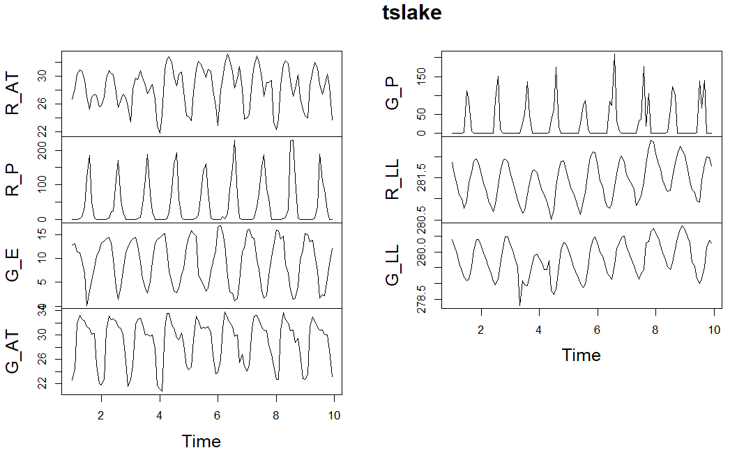

> ############### P and LL ######################
>
> ########### R_P ###############
>
> ######CCF R_P and R_LL ####################

ccf(lake$R_P, lake$R_LL)

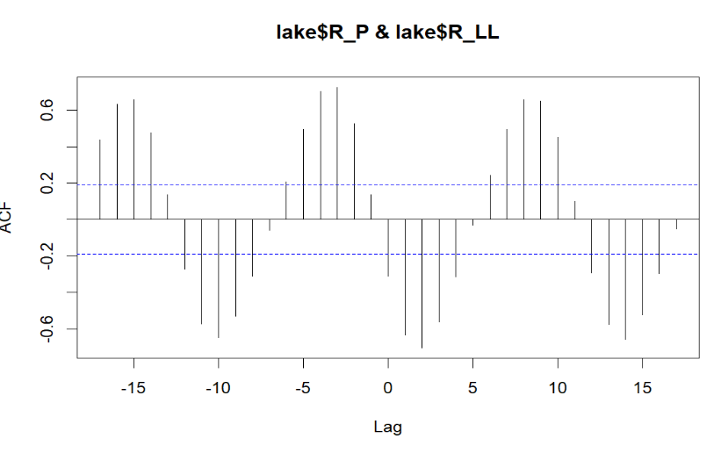
# ccf values
> ccfvalues = ccf(lake$R_P, lake$R_LL)
>
> ccfvalues

Autocorrelations of series ‘X’, by lag

-17 -16 -15 -14 -13 -12 -11
0.437 0.632 0.659 0.478 0.136 -0.270 -0.573
-10 -9 -8 -7 -6 -5 -4
-0.649 -0.531 -0.312 -0.058 0.208 0.494 0.703
-3 -2 -1 0 1 2 3
0.727 0.525 0.138 -0.311 -0.633 -0.705 -0.563
4 5 6 7 8 9 10
-0.314 -0.031 0.242 0.496 0.657 0.651 0.453
11 12 13 14 15 16 17
0.100 -0.293 -0.576 -0.657 -0.525 -0.295 -0.051

>

> #### Plotting the lagged r values
> # install.packages("astsa")
> library('astsa')
> lag2.plot(lake$R_P, lake$R_LL, 5, pch = 20, cex=3, lwl = 2)
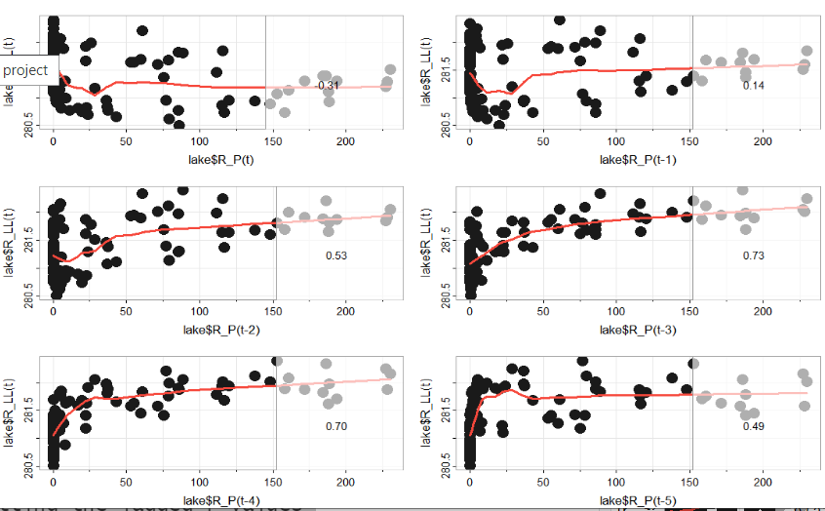

#####CCF R_P and G_LL ####################
>
> ccf(lake$R_P, lake$G_LL)

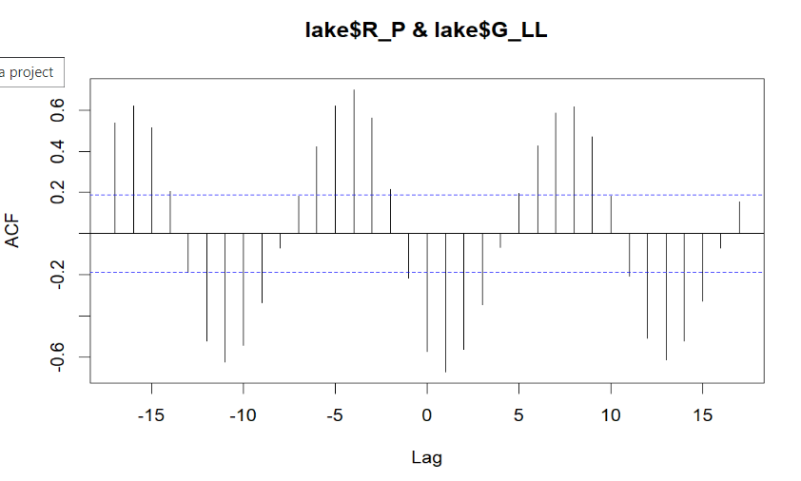
> # ccf values
> ccfvalues = ccf(lake$R_P, lake$G_LL)
>
> ccfvalues

Autocorrelations of series ‘X’, by lag

-17 -16 -15 -14 -13 -12 -11
0.539 0.620 0.515 0.205 -0.187 -0.522 -0.625
-10 -9 -8 -7 -6 -5 -4
-0.542 -0.336 -0.069 0.182 0.421 0.618 0.699
-3 -2 -1 0 1 2 3
0.563 0.216 -0.218 -0.572 -0.674 -0.564 -0.346
4 5 6 7 8 9 10
-0.067 0.194 0.426 0.586 0.615 0.471 0.180
11 12 13 14 15 16 17
-0.206 -0.508 -0.613 -0.522 -0.328 -0.070 0.154

> #### Plotting the lagged r values
>
> lag2.plot(lake$R_P, lake$G_LL, 5, pch = 20, cex=3, lwl = 2)

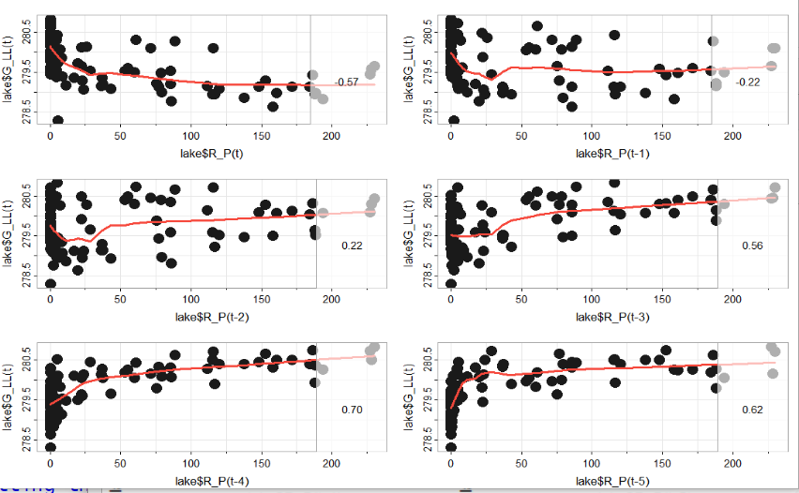

############ P_G ###############
>
> ######CCF G_P and R_LL ####################
>
> ccf(lake$G_P, lake$R_LL)

>

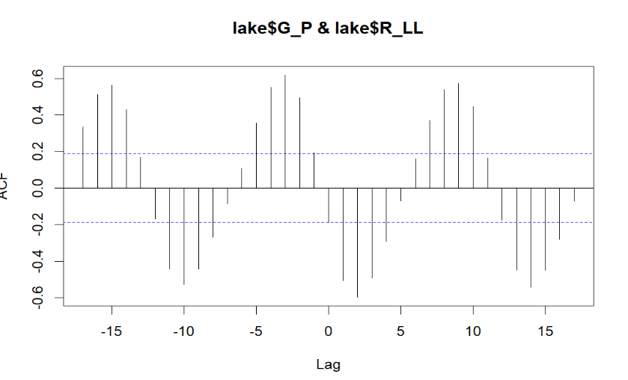
> ############ P_G ###############
>
> ######CCF G_P and R_LL ####################
>
> ccf(lake$G_P, lake$R_LL)
>
> # ccf values
> ccfvalues = ccf(lake$G_P, lake$R_LL)
> ccfvalues

Autocorrelations of series ‘X’, by lag

-17 -16 -15 -14 -13 -12
0.334 0.512 0.561 0.430 0.167 -0.169
-11 -10 -9 -8 -7 -6
-0.442 -0.527 -0.443 -0.268 -0.084 0.108
-5 -4 -3 -2 -1 0
0.354 0.552 0.618 0.495 0.191 -0.189
1 2 3 4 5 6
-0.506 -0.598 -0.492 -0.292 -0.069 0.160
7 8 9 10 11 12
0.370 0.540 0.571 0.446 0.165 -0.175
13 14 15 16 17
-0.449 -0.544 -0.450 -0.281 -0.071

> #### Plotting the lagged r values
>
> lag2.plot(lake$G_P, lake$R_LL, 5, pch = 20, cex=3, lwl = 2)
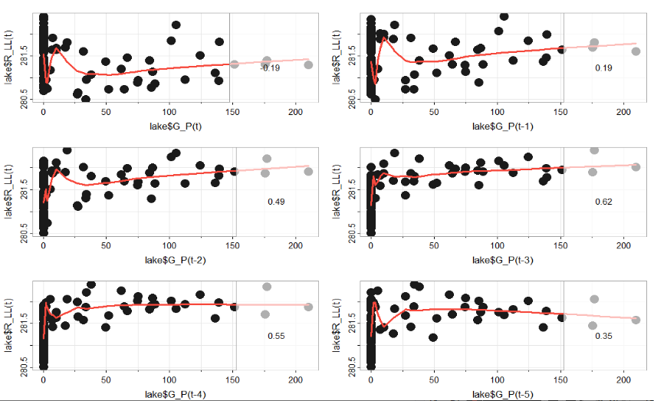
#####CCF G_P and G_LL ####################
>
> ccf(lake$G_P, lake$G_LL)
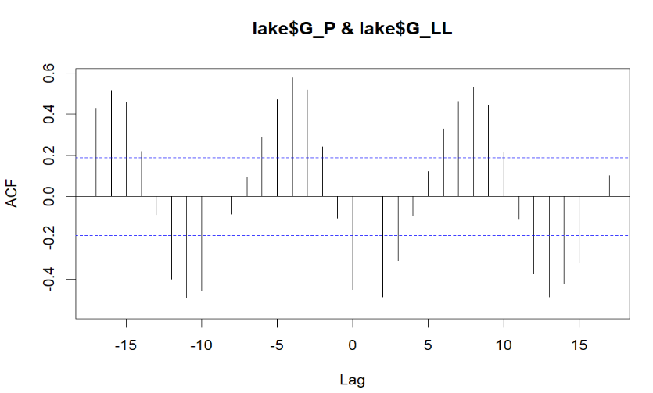
# ccf values
> ccfvalues = ccf(lake$G_P, lake$G_LL)
> ccfvalues

Autocorrelations of series ‘X’, by lag

-17 -16 -15 -14 -13 -12
0.429 0.516 0.460 0.219 -0.089 -0.401
-11 -10 -9 -8 -7 -6
-0.490 -0.461 -0.307 -0.086 0.094 0.291
-5 -4 -3 -2 -1 0
0.472 0.578 0.519 0.242 -0.104 -0.451
1 2 3 4 5 6
-0.550 -0.489 -0.311 -0.092 0.121 0.330
7 8 9 10 11 12
0.464 0.533 0.445 0.214 -0.109 -0.375
13 14 15 16 17
-0.488 -0.424 -0.320 -0.087 0.103

>

#### Plotting the lagged r values
>
> lag2.plot(lake$G_P, lake$G_LL, 5, pch = 20, cex=3, lwl = 2)

>

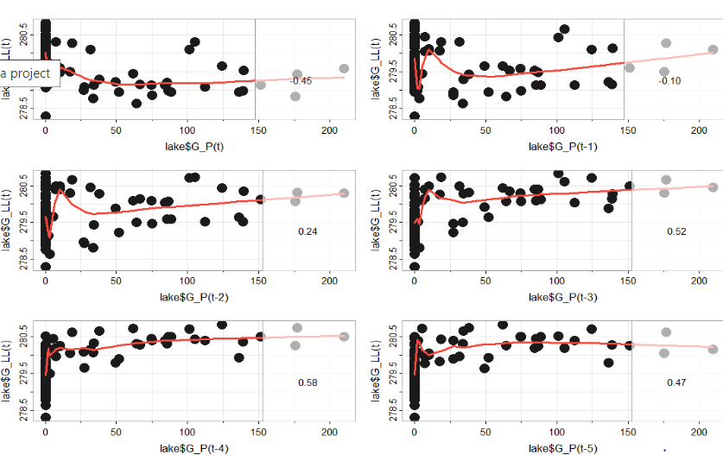
> #################### AT and LL ####################
>
>
> ########### AT_R ###############
>
> ######CCF R_AT and LL_R ####################
>
> ccf(lake$R_AT, lake$R_LL)
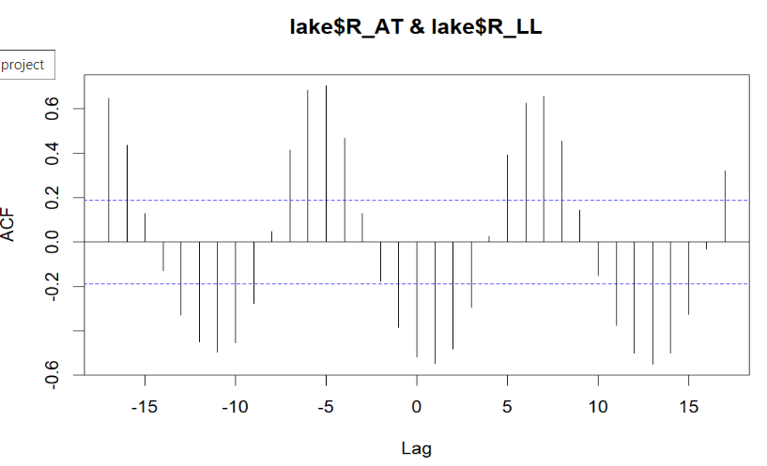
> # ccf values
> ccfvalues = ccf(lake$R_AT, lake$R_LL)
>
> ccfvalues

Autocorrelations of series ‘X’, by lag

-17 -16 -15 -14 -13 -12
0.649 0.435 0.129 -0.131 -0.329 -0.450
-11 -10 -9 -8 -7 -6
-0.497 -0.455 -0.275 0.048 0.414 0.686
-5 -4 -3 -2 -1 0
0.705 0.466 0.128 -0.178 -0.385 -0.519
1 2 3 4 5 6
-0.548 -0.481 -0.296 0.025 0.393 0.625
7 8 9 10 11 12
0.656 0.455 0.143 -0.153 -0.376 -0.501
13 14 15 16 17
-0.551 -0.501 -0.327 -0.030 0.320

> #### Plotting the lagged r values
>
> lag2.plot(lake$R_AT, lake$R_LL, 5, pch = 20, cex=3, lwl = 2)

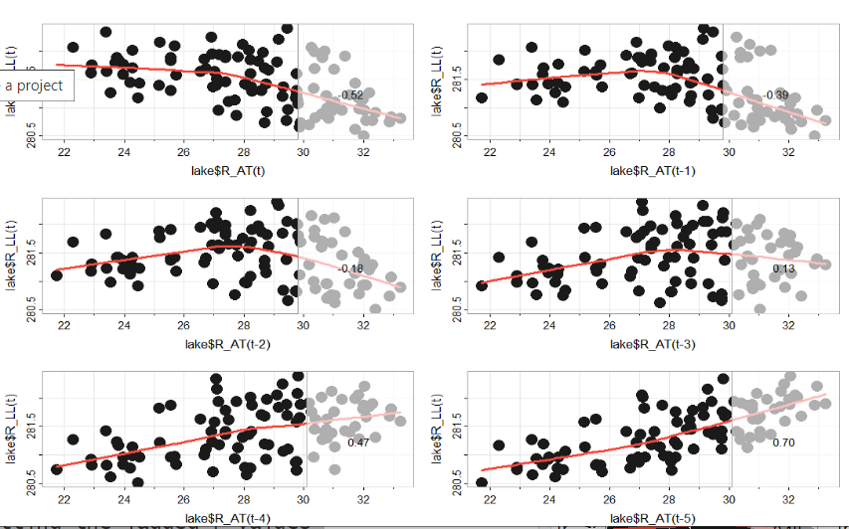

> #####CCF R_AT and LL_G ####################
>
> ccf(lake$R_AT, lake$G_LL)

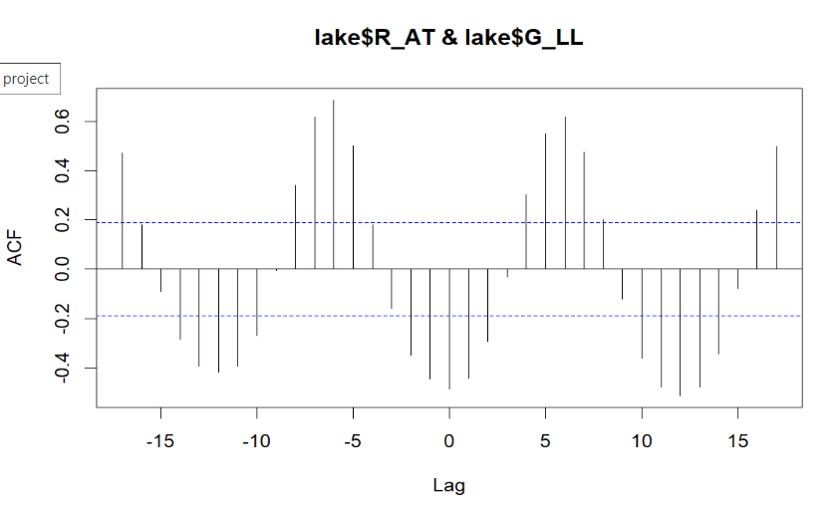
> # ccf values
> ccfvalues = ccf(lake$R_AT, lake$G_LL)
>
> ccfvalues

Autocorrelations of series ‘X’, by lag

-17 -16 -15 -14 -13 -12
0.472 0.180 -0.091 -0.285 -0.396 -0.419
-11 -10 -9 -8 -7 -6
-0.395 -0.271 -0.005 0.339 0.618 0.687
-5 -4 -3 -2 -1 0
0.500 0.180 -0.159 -0.350 -0.447 -0.488
1 2 3 4 5 6
-0.442 -0.295 -0.032 0.302 0.550 0.616
7 8 9 10 11 12
0.473 0.202 -0.120 -0.363 -0.478 -0.515
13 14 15 16 17
-0.479 -0.343 -0.080 0.239 0.497

### Plotting the lagged r values
>
> lag2.plot(lake$R_AT, lake$G_LL, 5, pch = 20, cex=3, lwl = 2)

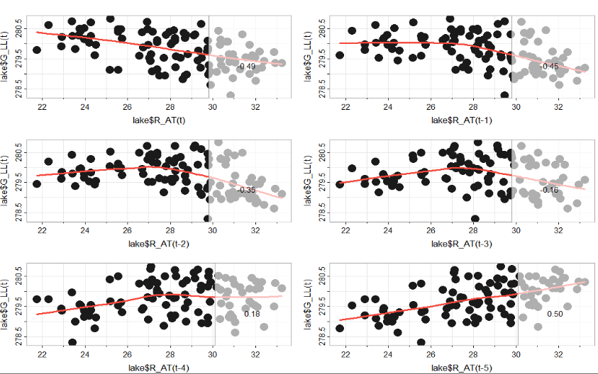

############ G_AT ###############
>
> ######CCF G_AT and LL_R ####################
>
> ccf(lake$G_AT, lake$R_LL)

>

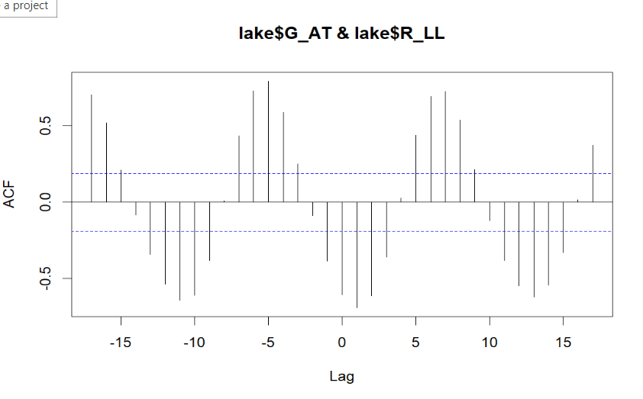

# ccf values
> ccfvalues = ccf(lake$G_AT, lake$R_LL)
>
> ccfvalues

Autocorrelations of series ‘X’, by lag

-17 -16 -15 -14 -13 -12
0.705 0.518 0.212 -0.084 -0.342 -0.535
-11 -10 -9 -8 -7 -6
-0.644 -0.611 -0.381 0.007 0.435 0.730
-5 -4 -3 -2 -1 0
0.794 0.590 0.252 -0.088 -0.386 -0.607
1 2 3 4 5 6
-0.692 -0.612 -0.361 0.025 0.439 0.693
7 8 9 10 11 12
0.726 0.540 0.216 -0.120 -0.381 -0.547
13 14 15 16 17
-0.621 -0.545 -0.328 0.016 0.374

> #### Plotting the lagged r values
>
> lag2.plot(lake$G_AT, lake$R_LL, 5, pch = 20, cex=3, lwl = 2)

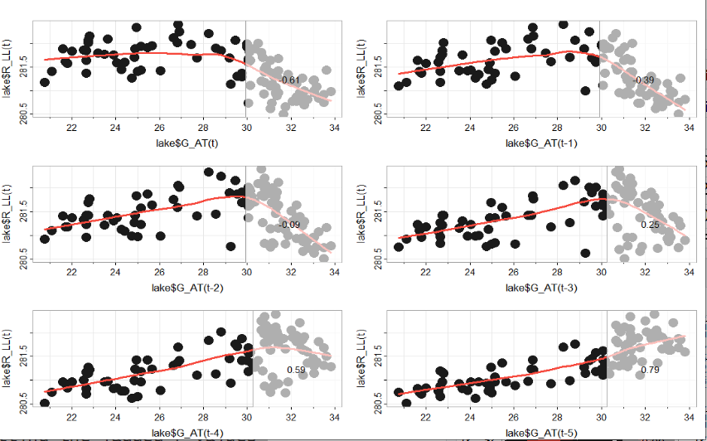
> #####CCF G_AT and G_LL ####################
>
> ccf(lake$G_AT, lake$G_LL)

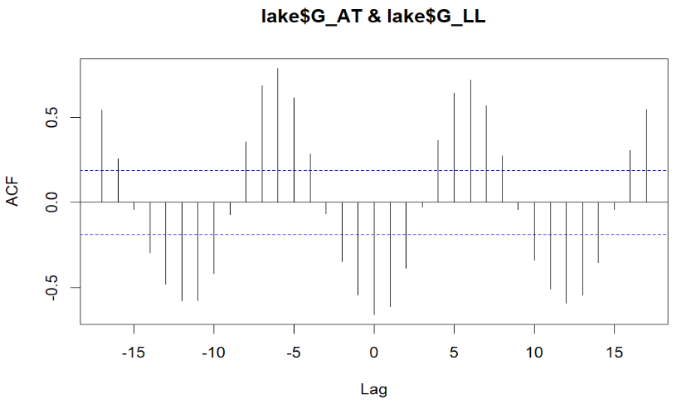
> # ccf values
> ccfvalues = ccf(lake$G_AT, lake$G_LL)
>
> ccfvalues

Autocorrelations of series ‘X’, by lag

-17 -16 -15 -14 -13 -12
0.540 0.255 -0.042 -0.297 -0.481 -0.576
-11 -10 -9 -8 -7 -6
-0.576 -0.417 -0.071 0.355 0.684 0.787
-5 -4 -3 -2 -1 0
0.613 0.283 -0.069 -0.348 -0.546 -0.660
1 2 3 4 5 6
-0.614 -0.387 -0.029 0.361 0.641 0.717
7 8 9 10 11 12
0.567 0.274 -0.042 -0.341 -0.510 -0.590
13 14 15 16 17
-0.543 -0.356 -0.043 0.305 0.544

> #### Plotting the lagged r values
>
> lag2.plot(lake$G_AT, lake$G_LL, 5, pch = 20, cex=3, lwl = 2)
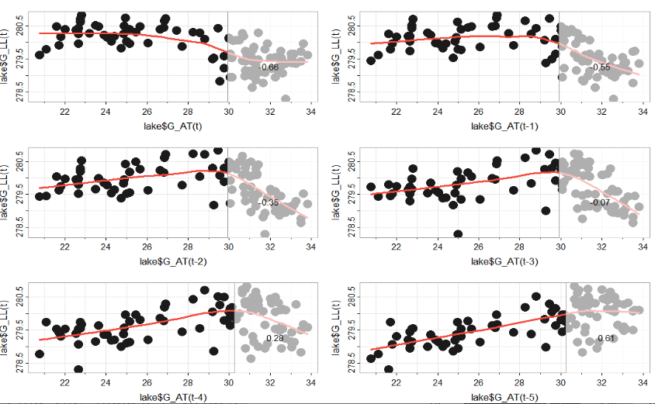

############################ E and LL #############################
>
> ############### R_E and LL ######################
>
> ########### R_E ###############
>
> ######CCF R_E and R_LL ####################
>
> ccf(lake$R_E, lake$R_LL)

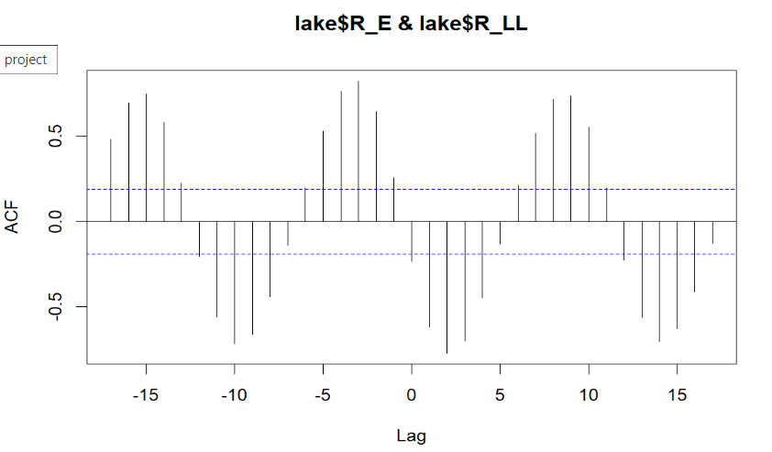

> # ccf values
> ccfvalues = ccf(lake$R_E, lake$R_LL)
>
> ccfvalues

Autocorrelations of series ‘X’, by lag

-17 -16 -15 -14 -13 -12
0.481 0.694 0.746 0.580 0.226 -0.205
-11 -10 -9 -8 -7 -6
-0.557 -0.717 -0.661 -0.439 -0.138 0.197
-5 -4 -3 -2 -1 0
0.529 0.764 0.823 0.644 0.254 -0.235
1 2 3 4 5 6
-0.616 -0.772 -0.702 -0.446 -0.131 0.215
7 8 9 10 11 12
0.518 0.714 0.735 0.554 0.197 -0.224
13 14 15 16 17
-0.560 -0.703 -0.630 -0.411 -0.128

> #### Plotting the lagged r values
>
> lag2.plot(lake$R_E, lake$R_LL, 5, pch = 20, cex=3, lwl = 2)

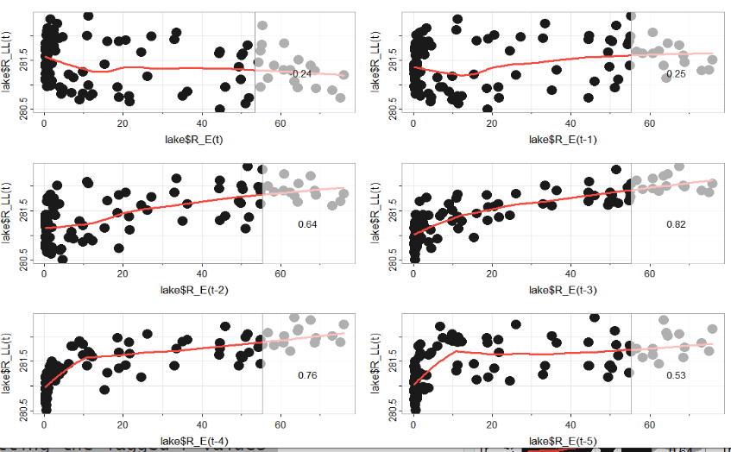

> #####CCF R_E and G_LL ####################
>
> ccf(lake$R_E, lake$G_LL)
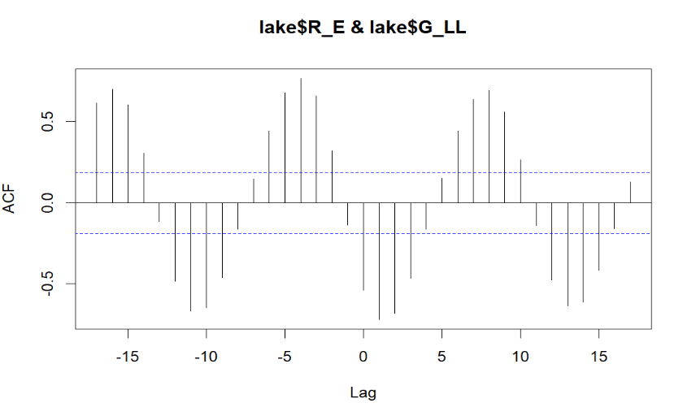
> # ccf values
> ccfvalues = ccf(lake$R_E, lake$G_LL)
>
> ccfvalues

Autocorrelations of series ‘X’, by lag

-17 -16 -15 -14 -13 -12
0.618 0.701 0.604 0.306 -0.116 -0.485
-11 -10 -9 -8 -7 -6
-0.672 -0.649 -0.466 -0.163 0.145 0.442
-5 -4 -3 -2 -1 0
0.680 0.769 0.659 0.319 -0.140 -0.542
1 2 3 4 5 6
-0.724 -0.687 -0.468 -0.164 0.149 0.442
7 8 9 10 11 12
0.639 0.694 0.560 0.265 -0.141 -0.478
13 14 15 16 17
-0.640 -0.614 -0.422 -0.160 0.127

#### Plotting the lagged r values
>
> lag2.plot(lake$R_E, lake$G_LL, 5, pch = 20, cex=3, lwl = 2)

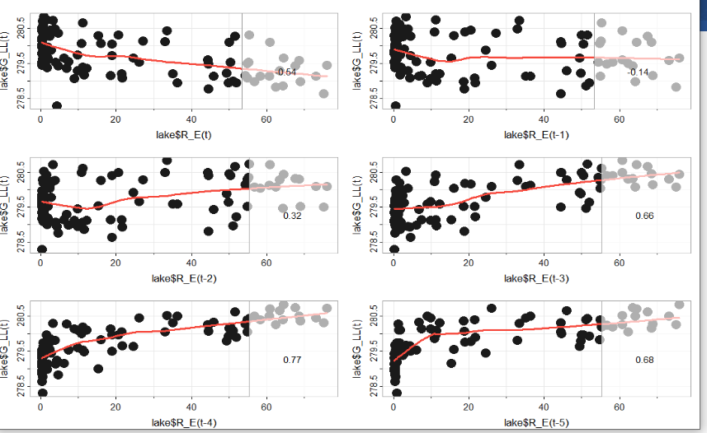

############ G_E ###############
>
> ######CCF E_G and R_LL ####################
>
> ccf(lake$G_E, lake$R_LL)
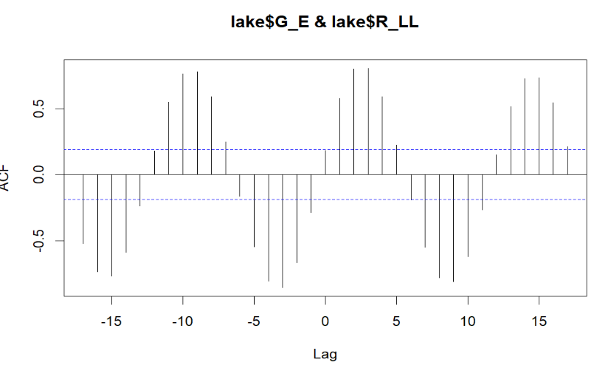

> # ccf values
> ccfvalues = ccf(lake$G_E, lake$R_LL)
>
> ccfvalues

Autocorrelations of series ‘X’, by lag

-17 -16 -15 -14 -13 -12
-0.520 -0.733 -0.767 -0.586 -0.239 0.178
-11 -10 -9 -8 -7 -6
0.549 0.763 0.779 0.588 0.250 -0.163
-5 -4 -3 -2 -1 0
-0.546 -0.803 -0.855 -0.665 -0.286 0.183
1 2 3 4 5 6
0.579 0.799 0.805 0.590 0.223 -0.192
7 8 9 10 11 12
-0.550 -0.780 -0.810 -0.619 -0.267 0.150
13 14 15 16 17
0.514 0.725 0.734 0.546 0.212

#### Plotting the lagged r values
>
> lag2.plot(lake$G_E, lake$R_LL, 5, pch = 20, cex=3, lwl = 2)

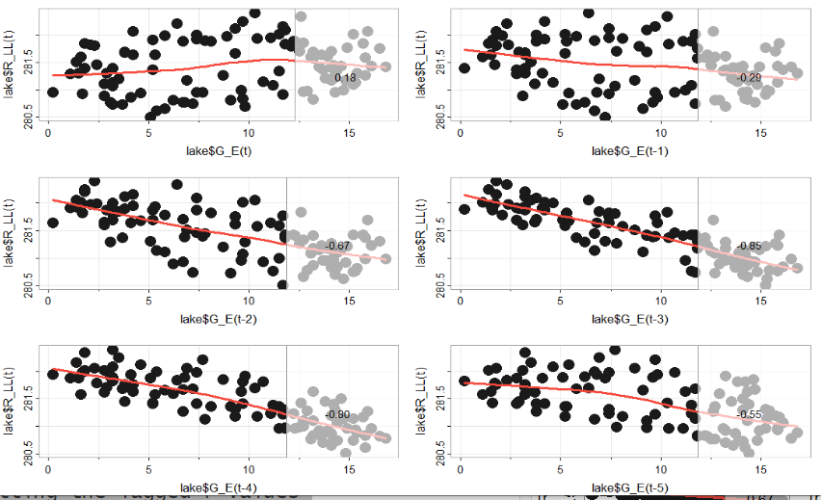

#####CCF G_E and G_LL ####################
>
> ccf(lake$G_E, lake$G_LL)

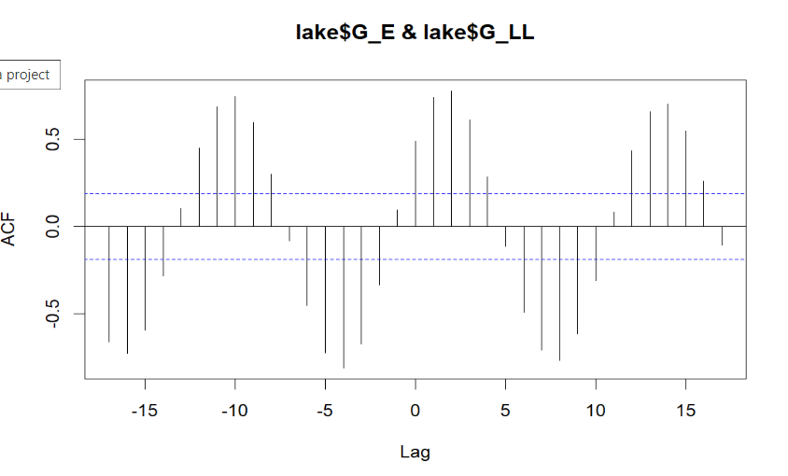
# ccf values
> ccfvalues = ccf(lake$G_E, lake$G_LL)
>
> ccfvalues

Autocorrelations of series ‘X’, by lag

-17 -16 -15 -14 -13 -12
-0.660 -0.729 -0.594 -0.284 0.101 0.449
-11 -10 -9 -8 -7 -6
0.686 0.742 0.595 0.300 -0.083 -0.452
-5 -4 -3 -2 -1 0
-0.723 -0.813 -0.673 -0.336 0.093 0.488
1 2 3 4 5 6
0.739 0.776 0.610 0.282 -0.117 -0.492
7 8 9 10 11 12
-0.710 -0.768 -0.614 -0.312 0.082 0.431
13 14 15 16 17
0.655 0.700 0.546 0.257 -0.106

>

#### Plotting the lagged r values
>
> lag2.plot(lake$G_E, lake$G_LL, 5, pch = 20, cex=3, lwl = 2)

